Class test: Introduction to Databases (CSD202)

SNU_ID: Max Marks: 4 marks

Q 1a. Check whether the given schedule S is conflict serializable or not. If yes, then determine all the possible equivalent serial schedules. (2.5)
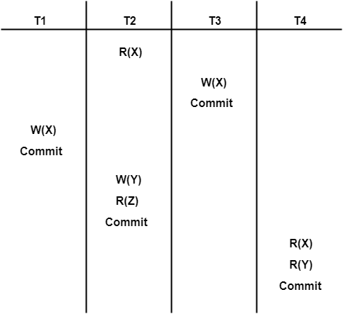

1b. Check whether the given schedule S is recoverable or not recoverable. If recoverable then which type of recoverable: cascadeless or not cascadeless or strict)\. Justify your answer. (1.5)

Solution-

Checking Whether S is Conflict Serializable Or Not-

Step-01:

List all the conflicting operations and determine the dependency between the transactions-
- R₂(X) , W₃(X) (T₂ → T₃)
- R₂(X) , W₁(X) (T₂ → T₁)
- W₃(X) , W₁(X) (T₃ → T₁)
- W₃(X) , R₄(X) (T₃ → T₄)
- W₁(X) , R₄(X) (T₁ → T₄)
- W₂(Y) , R₄(Y) (T₂ → T₄)

Step-02:
Draw the precedence graph-

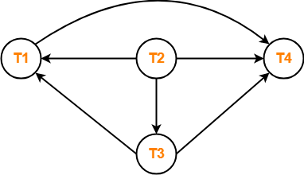

- Clearly, there exists no cycle in the precedence graph.
- Therefore, the given schedule S is conflict serializable.

Serial Schedules are:
T3-> T1->T4-> T2
T2->T1->T4->T3

Checking Whether S is Recoverable Or Not-

- Conflict serializable schedules are always recoverable.
- Therefore, the given schedule S is recoverable.
Alternatively,
- There exists no dirty read operation.
- This is because all the transactions which update the values commits immediately.
- Therefore, the given schedule S is recoverable.
- Also, S is a Cascadeless Schedule.

